**ADS2- CLIMATIC INDICATOR ANALYSIS**

**INTRODUCTION**

In our assignment, we have chosen both economic and climatic indicators for different countries around the globe. The primary focus is to identify the trend of these indicators with time. We have performed an inter-country analysis to know more about the relationship between different indicators for a particular nation.

**ANALYSIS**

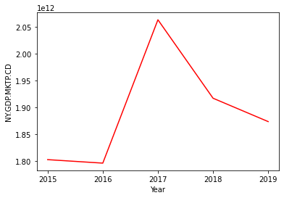 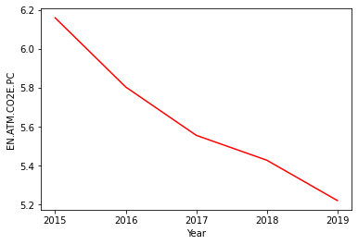

The above line plot indicates that the current GDP of Brazil reached a peak in the year 2017 but it has decreased after 2017

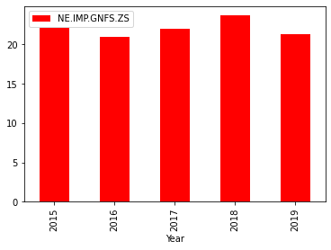

The above bar plot indicates that India's total import has increased from the year 2016 to the year 2018 but after 2018 it has decreased again.The above line plot indicates that Great Britain's carbon dioxide emissions in metric tons per capita has decreased from 2015 to 2019.

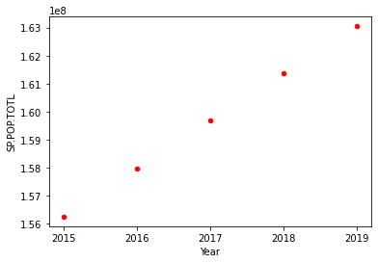

The above scatter plot indicates that Bangladesh's total population has increased from 2015 to 2019

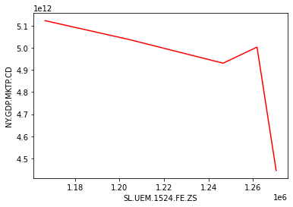 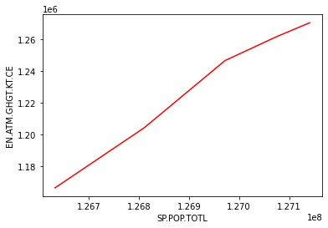

The line plot visualization is done to show the inter-country analysis where the country chosen is Japan. The visualization indicates that there is an indirect relationship between the current GDP and the Carbon dioxide emissions in metric tons per capita in Japan.

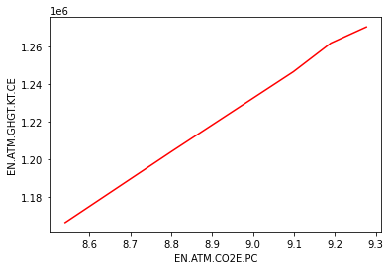

The line plot visualization is done to show the inter-country analysis where the country chosen is Japan. The visualization indicates that there is a direct relationship between the greenhouse gas emissions and the Carbon dioxide emissions in Japan.

**CONCLUSION**

* The current GDP of Brazil had reached its peak in the year 2017 but it has decreased after that till 2019
* The carbon dioxide emissions in metric tons per capita has shown a decreasing trend from 2015 to 2019 in Great Britain

The line plot visualization is done to show the inter-country analysis where the country chosen is Japan. The visualization indicates that there is a direct relationship between the total population and the greenhouse gas emissions in Japan.

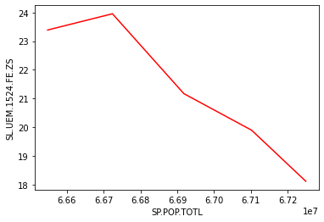

The line plot visualization is done to show the inter-country analysis where the country chosen is France. The visualization indicates that there is an indirect relationship between the total population and the female youth unemployment in France

* The inter- country results in the line plot shows that there is a direct relationship between total population and the greenhouse gas emissions, greenhouse gas emissions and the Carbon dioxide emissions in Japan
* The inter- country results in the line plot shows that there is an indirect relationship between the current GDP and the Carbon dioxide emissions in Japan and there is an indirect relationship between total population and female youth unemployment in France